Virtual Assistant for window

Electronics Department

**ABSTRACT:**

***Voice control is a major growing feature that change the way people can live. The voice assistant is commonly being used in smartphones and laptops. AI-based Voice assistants are the operating systems that can recognize human voice and respond via integrated voices. This voice assistant will gather the audio from the microphone and then convert that into text, later it is sent through GTTS (Google text to speech). GTTS engine will convert text into audio file in English language, then that audio is played using play sound package of python programming Language.***

**INTRODUCTION**

Today the development of artificial intelligence (AI) systems that are able to organize a natural human-machine interaction (through voice, communication, gestures, facial expressions, etc.) are gaining in popularity. One of the most studied and popular was the direction of interaction, based on the understanding of the machine by the machine of the natural human language. It is no longer a human learns to communicate with a machine, but a machine learns to communicate with a human, exploring his actions, habits, behaviour and trying to become his personalized assistant. The work on creating and improving such personalized assistants has been going on for a long time. These systems are constantly improving and improving, go beyond personal computers and have already firmly established themselves in various mobile devices and gadgets. One of the most popular voice assistants are Siri, from Apple, Amazon Echo, which responds to

the name of Alex from Amazon, Cortana It has some new features like posting comments on the social media websites such as Facebook, Twitter, etc. By just few simple commands. You can also know the weather around you and can get the climate conditions in your region. It can open and launch web-applications and the local storage of the user computer.

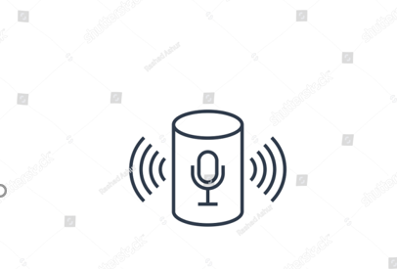

Fig1.Voice assistant

**RELATED WORK**

Each company-developer of the intelligent assistant applies his own specific methods and approaches for development, which in turn affects the final product. One assistant can synthesize speech more qualitatively, another can more accurately and without additional explanations and corrections perform tasks, others are able to perform a narrower range of tasks, but most accurately and as the user wants. Obviously, there is no universal assistant who would perform all tasks equally well. The set of characteristics that an assistant has depends entirely on which area the developer has paid more attention. Since all systems are based on machine learning methods and use for their creation huge amounts of data collected from various sources and then trained on them, an important role is played by the source of this data, be it search systems, various information sources or social networks. The amount of information from different sources determines the nature of the assistant, which can result as a result. Despite the different approaches to learning, different algorithms and techniques, the principle of building such systems remains approximately the same. Figure 1 shows the technologies that are used to create intelligent systems of interaction with a human by his natural language. The main technologies are voice activation, automatic speech recognition, Teach-To-Speech, voice biometrics, dialog manager, natural language understanding and named entity recognition.

**PROPOSED PLAN OF WORK**

The work started with analyzing the audio commands given by the user through microphone. This can be anything like getting any information, operating computer’s internal files, etc. This is an empirical qualitative study, based on reading above mentioned literature and testing their examples. Tests are made by programming according to books and online resources, with the explicit goal to find best practices and a more advanced understanding of Voice Assistant.

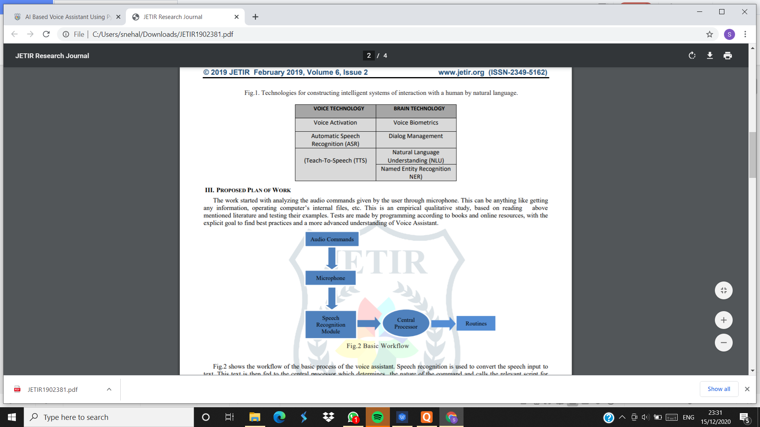

Fig2. Basic Workflow

Fig. shows the workflow of the basic process of the voice assistant. Speech recognition is used to convert the speech input to text. This text is then fed to the central processor which determines the nature of the command and calls the relevant script for execution. but, the complexities don’t stop there. Even with hundreds of hours of input, other factors can play a huge role in whether or not the software can understand you. Background noise can easily throw a speech recognition device off track. This is because it does not inherently have the ability to distinguish the ambient sounds it “hears” of a dog barking or a helicopter flying overhead, from your voice. Engineers have to program that ability into the device; they conduct data collection of these ambient sounds and “tell” the device to filter them out. Another factor is the way humans naturally shift the pitch of their voice to accommodate for noisy environments; speech recognition systems can be sensitive to these pitch changes.

**METHODOLOGY**

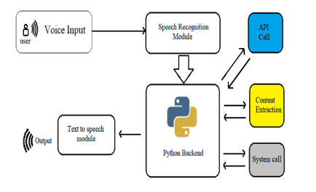 Fig3. Detailed Workflow

**Speech Recognition:**

The system uses Google’s online speech recognition system for converting speech input to text. The speech input Users can obtain texts from the special corpora organized on the computer network server at the information center from the microphone is temporarily stored in the system which is then sent to Google cloud for speech recognition. The equivalent text is then received and fed to the central processor.

**Text-To-Speech:**

Text-to-Speech (TTS) refers to the ability of computers to read text aloud. A TTS Engine converts written text to a phonemic representation, then converts the phonemic representation to waveforms that can be output as sound. TTS engines with different languages, dialects and specialized vocabularies are available through third-party publishers.

Conclusion In this paper, we discussed the design and implementation of a Digital Assistance. The project is built using open source software modules with PyCharm community backing which can accommodate any updates in the near future. The modular nature of this project makes it more flexible and easy to add additional features without disturbing current system functionalities. It not only works on human commands but also give responses to the user on the basis of query being asked or the words spoken by the user such as opening tasks and operations. It is greeting the user the way user feels more comfortable and feels free to interact with the voice assistant. The application should also eliminate any kind of unnecessary manual work required in the user life of performing each and every task. The entire system works on the verbal input rather than the text one.

**OUTPUT:**

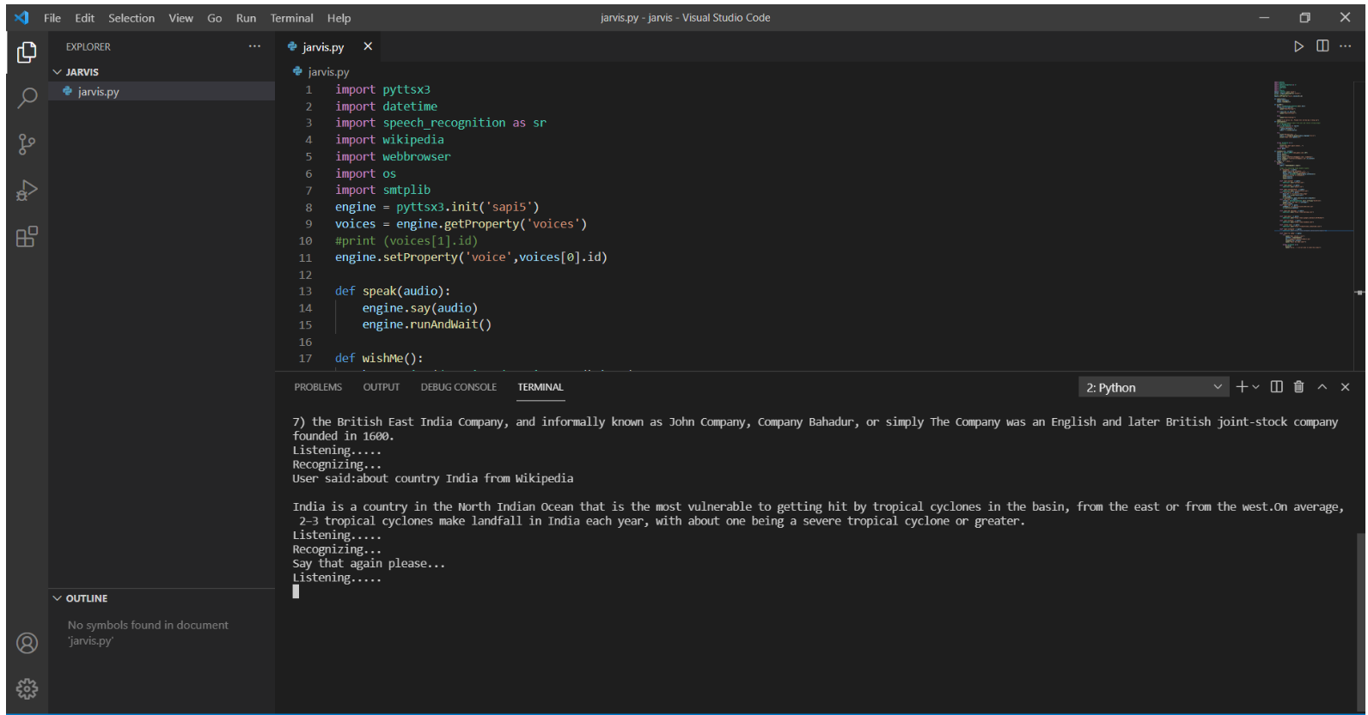

Fig4.searching information from Wikipedia using voice assistant

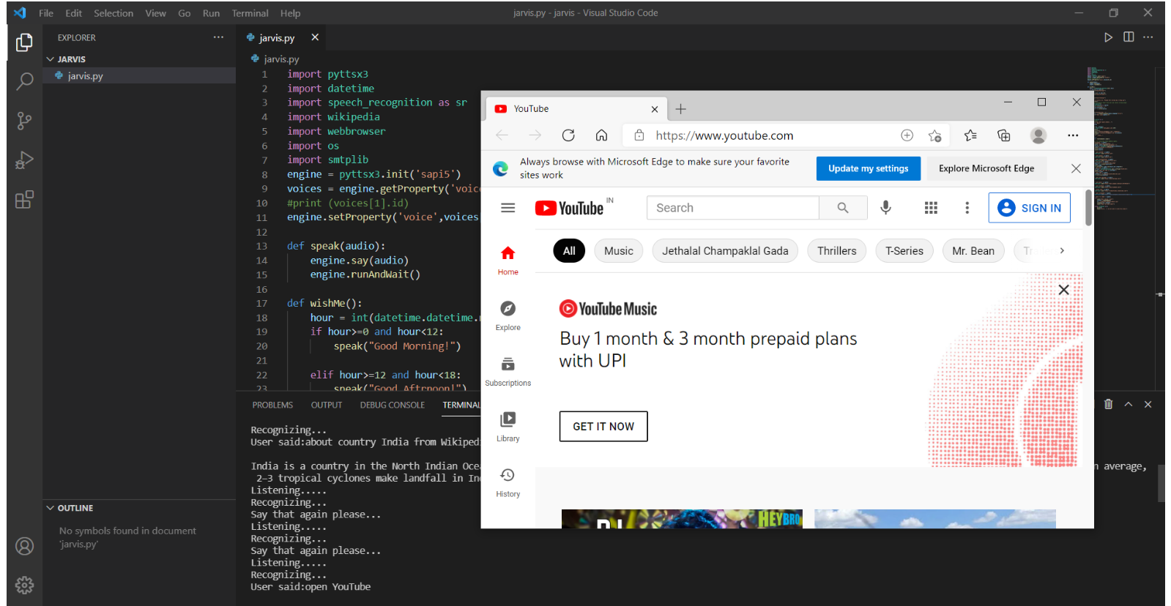

Fig5. Opened the YouTube

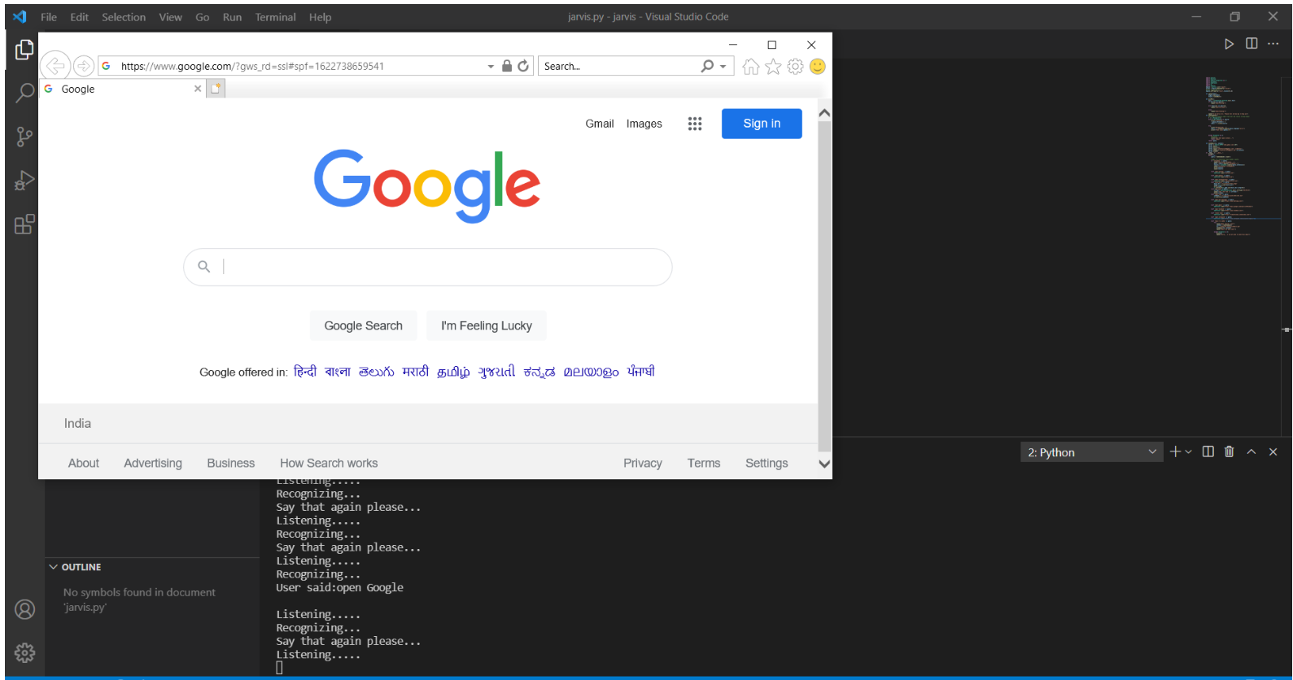

Fig6: Opened the google

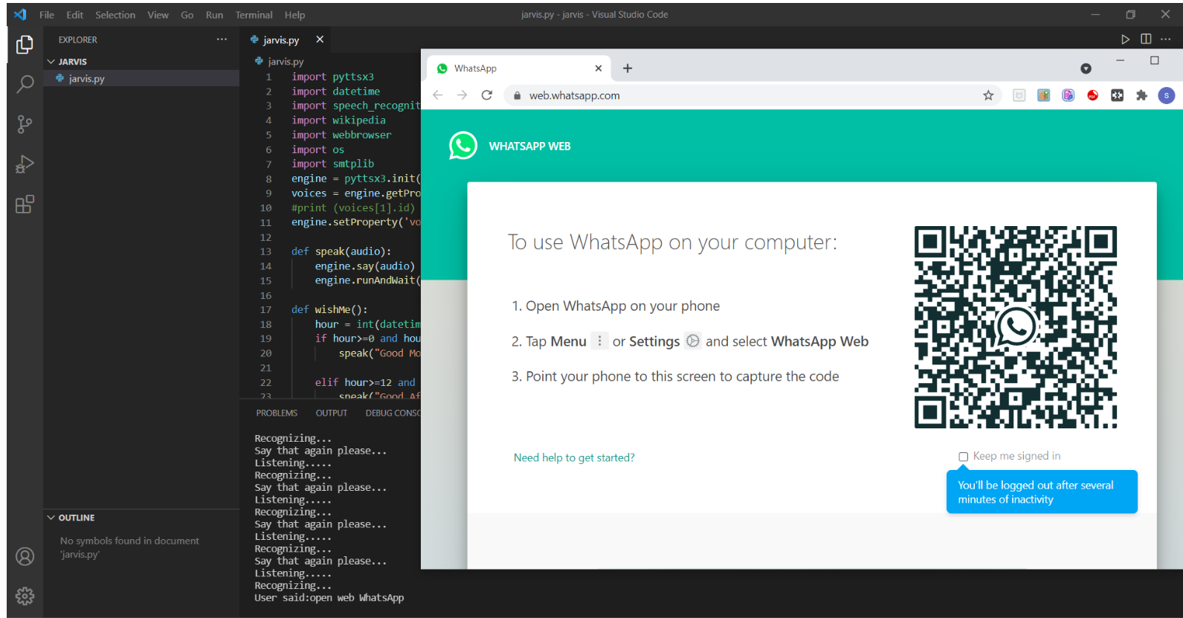

Fig7: Opened the WebWatsa

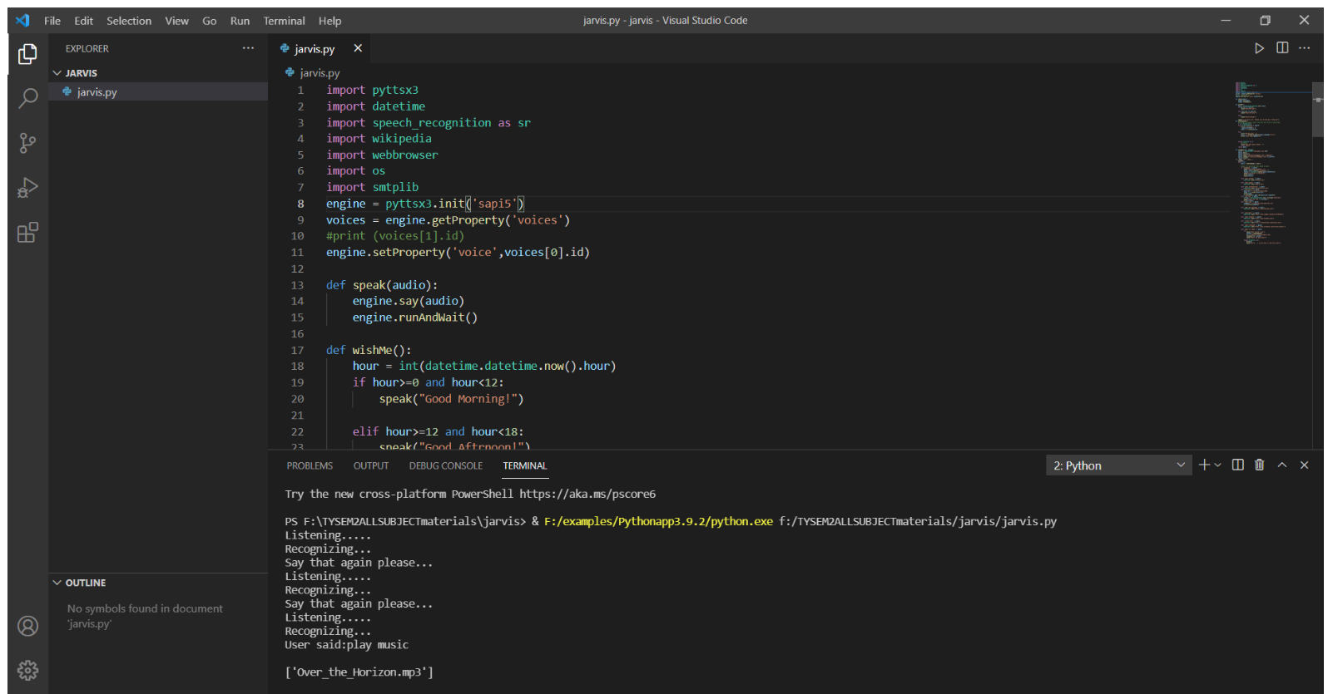

Fig8: Playing music stored in my laptop

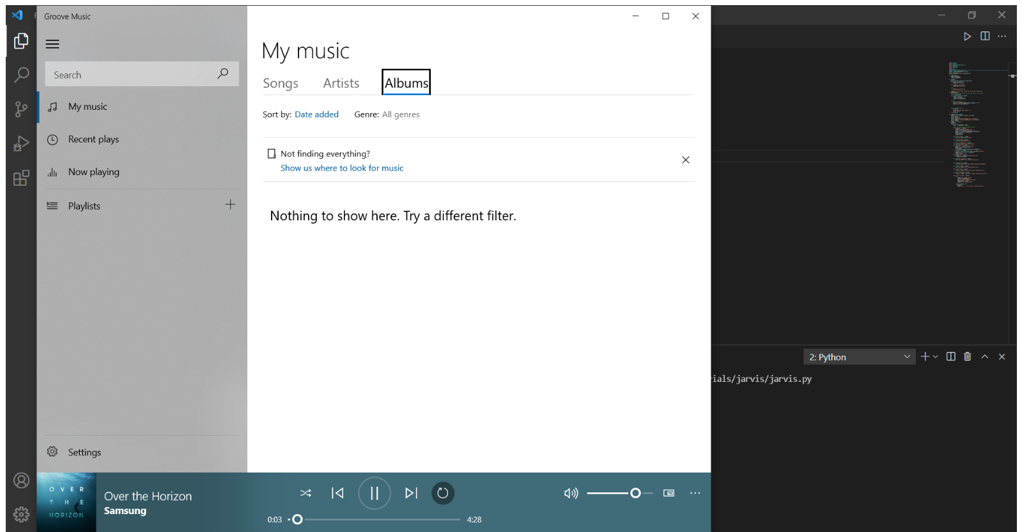

Fig9: Played the music stored in my laptop

**CONCLUSION:**

AI-based Google Assistant which was supposed to be a multi-platform interactive voice assistant. Given the extent of Google services, Android devices and Chrome, the majority of Internet users have a Google account collecting their data. A virtual assistant’s primary role is to recognize and assess the user’s voice and speech. They do this by recording the spoken phrase and analyzing it with AI-based Natural Language Processing (NLP) algorithms. It’s pretty obvious that voice recognition has to be on point for the users to like and continue using the assistant.

**RFERENCES:**

[1] Webopedia, web page [Online]. Available:https://www.webopedia.com/TERM/I/intellige nt-personal-assistant.html’

[2] Aditya Sinha, Gargi Garg, GouravRajwani, Shimona Tayal, “Intelligent Personal Assistant”. International Journal of Informative & Futuristic Research, Volune. 4, Issue 8, April 2017.

[3] Statista, web page [Online]. Available:https://www.statista.com/statistics/973815/wor ldwide-digital-voice-assistant-in-use/

[4] Bibek Behera, “Chappie - A Semi-automatic Intelligent Chatbot”.